**Book Store App Project Report**

# Introduction

This project, the Book Store App, is a full-stack application designed to provide a seamless and immersive experience for book enthusiasts. It serves as a digital platform for exploring, discovering, and purchasing books, catering to a wide range of users from avid readers to casual browsers. The application aims to revolutionize the traditional bookstore experience by integrating modern technology with the love of reading.

# Project Overview: What I Did

I developed a comprehensive Book Store Application leveraging the MERN (MongoDB, Express.js, React, Node.js) Stack. The core objective was to create an intuitive and functional platform where users can browse, search, purchase, and manage their literary acquisitions. The project includes features for user management, inventory control, and order processing, with distinct roles for users, sellers, and administrators.

Specifically, I implemented the following key functionalities:

* **User Registration and Authentication**: Securely allowing users to create accounts, log in, and authenticate their identity.

* **Book Listings and Browse**: Displaying a comprehensive list of available books with detailed information such as title, author, genre, description, price, and availability. Users can filter and explore books based on categories and genres.

* **Purchase Process**: Enabling users to add books to a cart, specify quantities, and complete secure purchases. Upon successful order, the inventory is updated.

* **Order Management**: Providing order confirmation details to users and allowing them to view their past and current orders, including tracking shipments and reviewing purchased books.

* **Admin and Seller Dashboards**: Creating interfaces for administrators to manage book listings, inventory, user accounts, and orders, and for sellers to manage their products and fulfill orders.

# How I Did It: Technical Implementation

My approach followed a structured development process across five key milestones, utilizing the MERN stack for both frontend and backend development.

## Technical Architecture

The application's architecture is modular and scalable, built around distinct services communicating via an API Gateway.

* **User Interface (UI)**: Developed using React.js, this is the interactive and visually appealing front-end where users interact with the application. It is designed to be responsive across various devices.

* **Web Server**: Hosts the React.js UI and serves dynamic web pages, ensuring a smooth Browse experience.

* **API Gateway**: Serves as the central entry point for all client requests, routing them to the appropriate backend services such as authentication, book information retrieval, and order processing.

* **Authentication Service**: Manages user authentication and authorization, safeguarding sensitive user data and access.

* **Database**: MongoDB is used as the persistent data store for books, user profiles, purchase history, and other critical entities.

* **Inventory Management Service**: Handles book availability, stock levels, and ratings, ensuring efficient inventory control.

* **Order Management Service**: Facilitates the complete ordering process, from adding items to the cart to secure purchases and real-time order tracking.

## Database Design (ER Diagram)

I designed the database using Mongoose schemas based on the Entity-Relationship (ER) diagram. Key relationships implemented include:

* **User-Book Relationship**: A many-to-many relationship managed by an Interaction table (or schema in MongoDB) to store user-specific book data like reading progress or reviews.

* **Book-Inventory Relationship**: A one-to-many relationship where each book can have multiple copies in inventory, tracked by a separate Inventory table/schema with fields like BookID, quantity, location, and condition.

* **User-Order Relationship**: A one-to-many relationship where a single user can place multiple orders, with UserID as a foreign key in the Order table/schema.

* **Additional Relationships**: I also established many-to-many relationships for BookAuthor (via a WrittenBy table/schema) and Book-Genre (via a CategorizedAs table/schema), and a many-to-one relationship for Review-User (with UserID in the Review table/schema).

## Project Flow (User Journey)

I mapped out the user flow to ensure a logical and intuitive experience:

1. **Start**: Users launch the app.

1. **View Books**: Users land on the home page, providing an overview of offerings.

1. **Search Books**: Users can search for specific titles or authors.

1. **Select Genre**: Users can filter books by genre for refined Browse.

1. **Select Book**: Users choose a book to view details.

1. **Add to Cart**: Users add selected books to their cart.

1. **Order Book**: Users proceed to complete the purchase, specifying quantities and confirming the order.

1. **View Orders**: Users can view their current and past orders.

1. **End**: The flow concludes after the user completes their actions.

## Development Milestones

My development process was structured into the following milestones:

* Milestone 1: Project Setup and Configuration :
  1. Installed Node.js, npm, MongoDB, and initiated the React application using create-react-app (or Vite).

○ Created

client (frontend) and server (backend) folders.

○ Installed necessary npm packages for both frontend ( axios, react-router-dom, bootstrap, react-bootstrap) and backend (express, mongoose, cors).

* Milestone 2: Backend Development :
  1. Set up an Express server by creating index.js and configuring environment variables in a .env file.

○ Configured middleware like cors and body-parser.

○ Implemented user authentication routes and middleware for registration, login, and logout.

○ Defined API routes for core functionalities (users, orders, authentication) and implemented route handlers using Express.js to interact with the database.

○ Defined Mongoose schemas and models for data entities (products, users, orders) and implemented CRUD operations.

○ Implemented error handling middleware to provide informative error responses.

* Milestone 3: Database :
  1. Configured MongoDB by installing Mongoose and establishing the database connection.

○ Ensured the database connection was active before any backend operations.

○ Configured MongoDB schemas (

UserSchema example provided) to define the data structure based on the ER diagrams.

* Milestone 4: Frontend Development :
  1. Set up the React application, configured routing, and installed required libraries.

○ Designed the UI components, implemented the layout and styling, and added navigation elements.

○ Implemented frontend logic, including integration with API endpoints and data binding.

* Milestone 5: Project Implementation and Testing :
  1. After completing the coding, I thoroughly ran and tested the entire project to ensure its functionality and identify any bugs.

○ Demonstrated the working of various application pages, including the Landing page , Login page , Home page , Books page , Wishlist page , My Orders page , Seller Dashboard , Seller Items , Admin Dashboard , Users page , User Orders , and Sellers page.

# Technologies Used

* **Frontend**: React.js, HTML, CSS, JavaScript, Axios, React-Router-DOM, Bootstrap, ReactBootstrap.

* **Backend**: Node.js, Express.js, Cors, Body-Parser.

* **Database**: MongoDB, Mongoose.

* **Version Control**: Git.

* **Development Environment**: Visual Studio Code (or similar IDE).

**5.PROJECT PLANNING & SCHEDULING**

5.1 Project Planning Timeline:

• Requirement gathering, tech stack finalization

• Backend API development • Frontend integration

• Testing and deployment

# 6.FUNCTIONAL AND PERFORMANCE TESTING

6.1 Performance Testing Tested using tools like Postman for API response time, Lighthouse for frontend performance.

**7. RESULTS**

**7.1 Output Screenshots Include screenshots for:**

**• Home page**

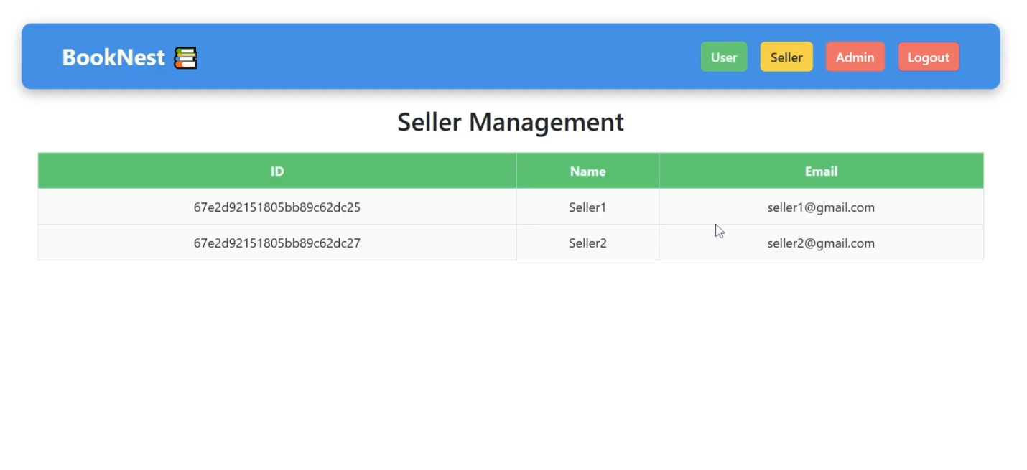

**• Login/Signup**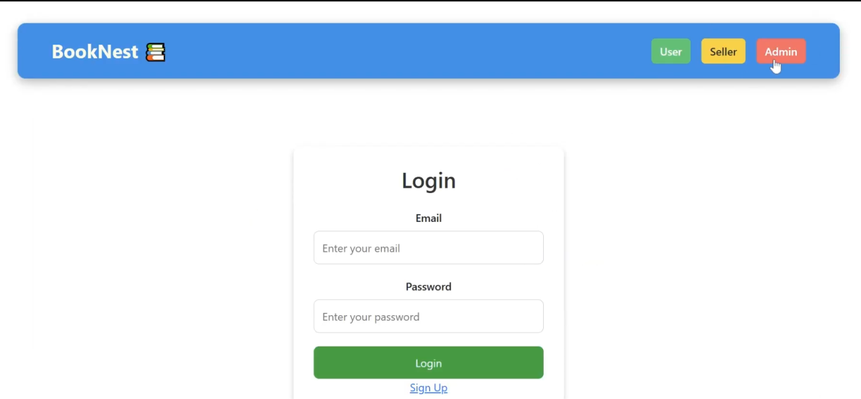

**• Book listings**

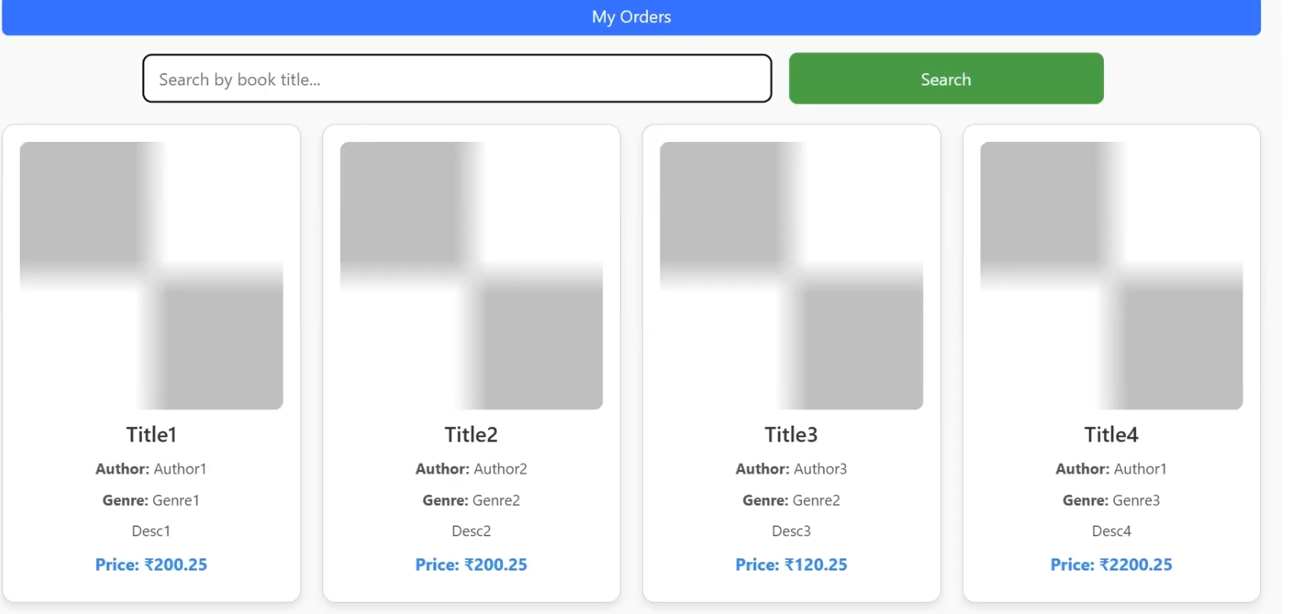

**• Seller dashboard**

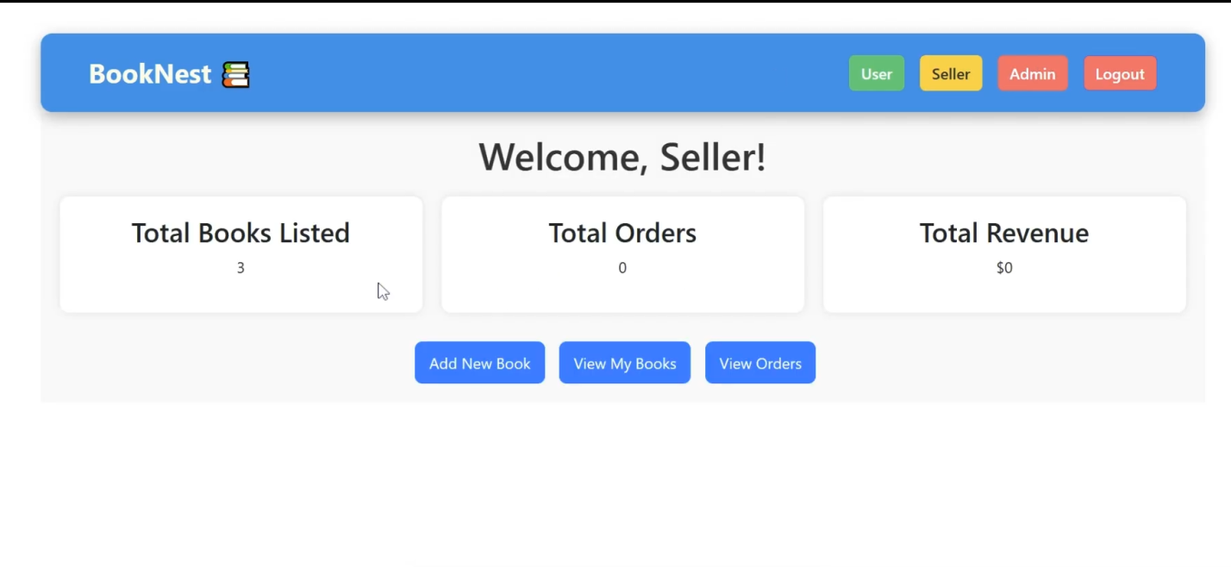

**8. ADVANTAGES & DISADVANTAGES Advantages**

• Cross-role platform

• Real-time updates

• Scalable design Disadvantages

• Requires internet access

• Initial server cost for hosting

**5.Conclusion**

This Book Store App successfully demonstrates a complete full-stack application built with the MERN stack. It addresses the need for a convenient and feature-rich platform for book lovers, providing secure user authentication, extensive book Browse capabilities, efficient purchase processes, and robust administrative tools. The project showcases the integration of modern web technologies to deliver a dynamic and user-friendly experience in the digital literary world.

**10.FUTURE SCOPE**

• Add payment gateway integration

• Recommendation engine using ML

• Mobile app version

**11.APPENDIX**

• Source Code: https://github.com/hemalatha256/booknestle/tree/master/backend

• Dataset Link: N/A (Data entered manually)

• Project Demo: https://github.com/hemalatha256/booknestle/blob/master/booknestvid.mp4